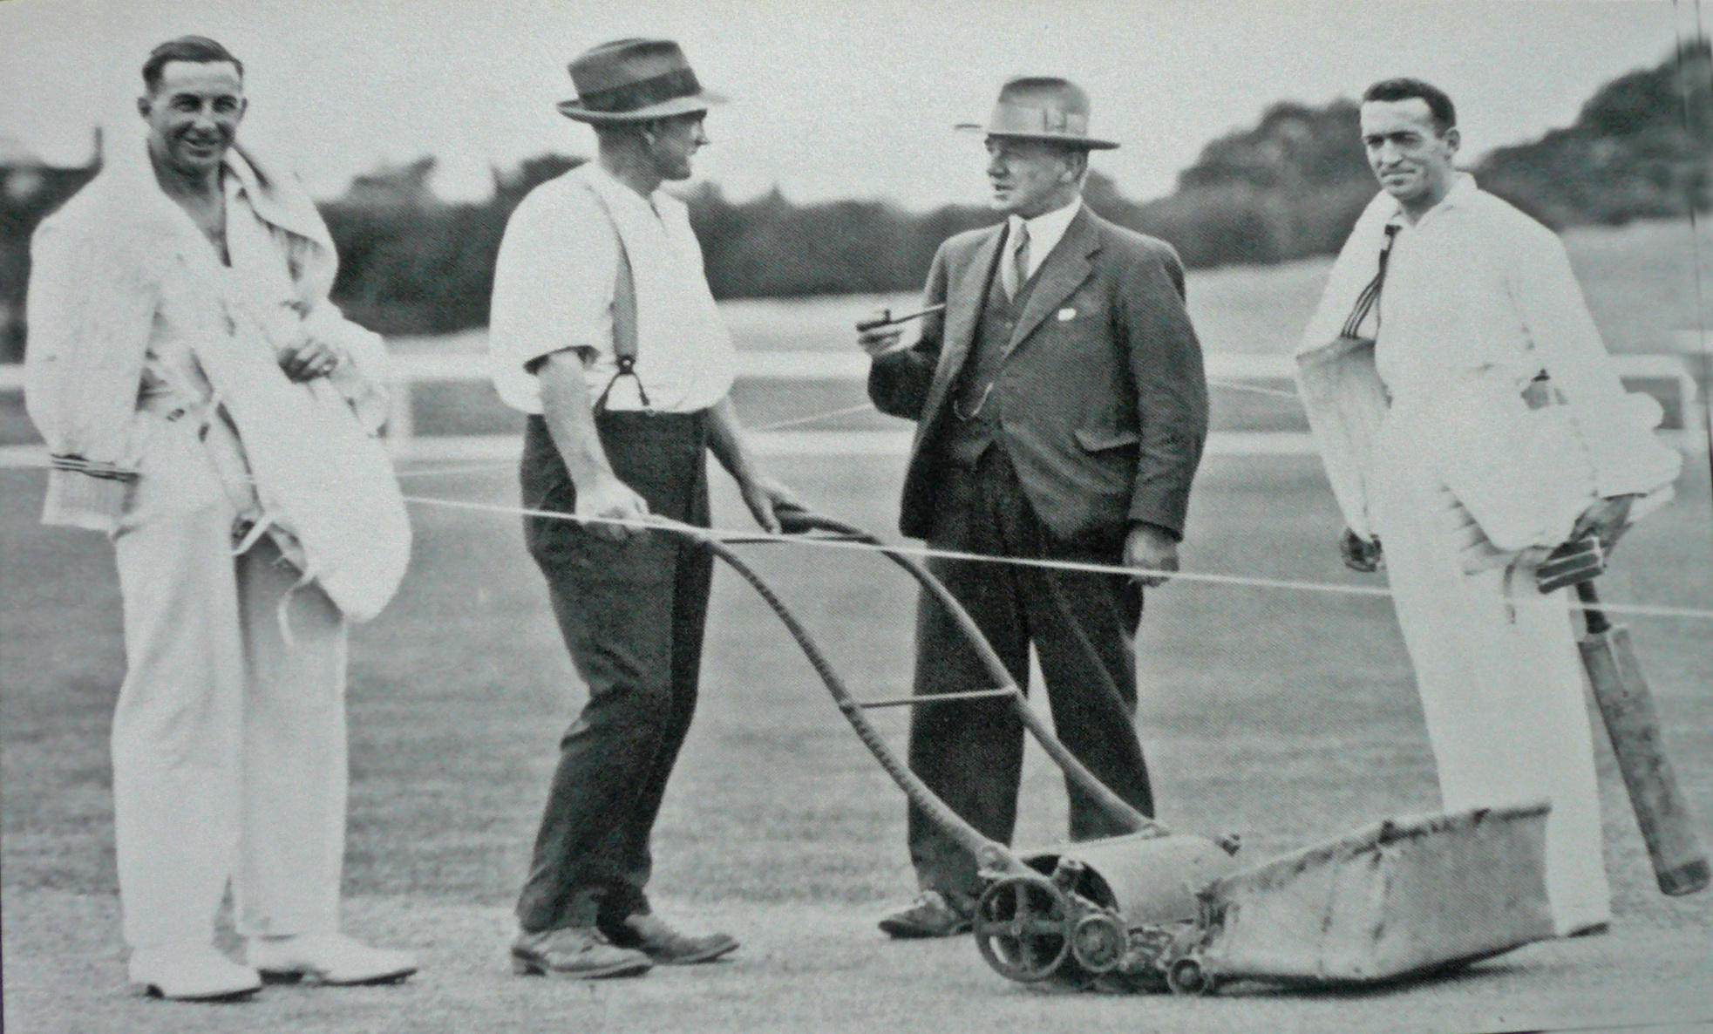

**Lancaster Park 23 December 1933. Cutting the pitch prior to play FT Badcock, TH Hallam, AT Donnelly, ML Page**

Otago 353 & 299 Canterbury 217 & 339. Canterbury lost by 96 runs